Press Release

Richard Patterson|Ged Quinn

Private View: 24 May 2018
Exhibition dates: 25 May – 14 July 2018
Curated by Catherine Loewe

Galleria Mucciaccia
Largo della Fontanella di Borghese 89
Rome, Italy
https://www.galleriamucciaccia.it

Galleria Mucciaccia is delighted to present an exhibition featuring the work of two highly acclaimed British artists Richard Patterson and Ged Quinn showing for the first time together in Rome. The exhibition presents an overview from across their respective oeuvres up to the present day. Patterson and Quinn were both born in 1963 in the UK and emerged during the pivotal period in late 1980’s London when British art gained international recognition. This era represented a paradigm shift, characterized by the mixed-media conceptual art prevalent at the time but also by a sense of emancipation from both the conventions of postmodernist doctrine and the established hierarchies of the art world. The work of Patterson and Quinn can be seen as having its roots within this milieu - the multi-layered approach to source material and process, the inclination towards appropriation and the resurgence of the polemics of painting. In this context Patterson and Quinn can be distinguished by their resolute exploration of the power of the image and the possibilities inherent in the medium of painting.

Both artists studied in London, Quinn at the Slade, continuing his studies in Germany and the Netherlands before moving to rural Cornwall in the UK and Patterson at Goldsmiths, subsequently leaving London for New York and Dallas in the USA. Over three decades of artistic practice, Patterson and Quinn have refined their creative vision and technical brilliance to forge distinctive interpretations that reflect both a profound personal and cultural consciousness. Both employ a multitude of forms, idioms and genres, the disparate and contradictory elements of which might appear random, but are in fact carefully extracted and painstakingly rendered. We are visually hooked from the first moment by the sheer bravura of the work – whether epic or tiny, abstract or photorealistic, but no matter how seductive the painted surface, this is far from complacent art. Assimilating in parallel the enduring dialectic between figuration and abstraction, past and present, fact and fiction, sacred and profane, high and popular culture, this exhibition establishes a compelling dialogue between these two renowned artists.

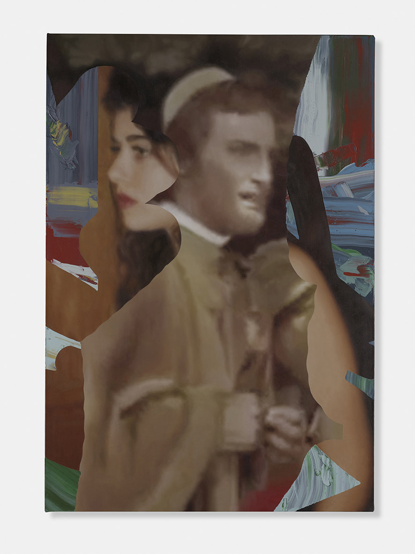
RICHARD PATTERSON, Modern Love, 2017, Oil on canvas,
58 x 40 in, 147.3 x 101.6 cm
© The artist and Timothy Taylor Gallery, London

Richard Patterson’s complex, multi-layered paintings sit firmly within the grand tradition of European and American art. Despite their rich pop cultural allusions culled from film, magazines, music and advertising, Patterson is engaged on a philosophical level with the interconnections of meaning, image and making. His works can be viewed as masks or screens, concealing a melancholy meditation on the contemporary condition. Patterson knowingly employs a battery of techniques, genres and media: self-portraits, ready-mades, photography, painterly streaks and smudges and virtuoso photorealist painting, which all converge in works that reveal the inherently political nature of craft and making.
Born in the UK in 1963, Patterson graduated from Goldsmiths College in 1986. He was included in Damien Hirst’s renowned Freeze, Surrey Docks, London (1988); as well as Sensation: Young British Artists from the Saatchi Collection, Royal Academy of Arts, London, UK; Hamburger Bahnhof – Museum für Gegenwart, Berlin, Germany; Brooklyn Museum of Art, New York, USA (1997-00). Other notable exhibitions include The Rowan Collection: Contemporary British & Irish Art, Irish Museum of Modern Art, Dublin, Ireland (2002); Painting Pictures, Kunstmuseum Wolfsburg, Germany (2003); Nexus Texas, Contemporary Arts Museum Houston, Texas, USA (2007) and Attention to Detail, curated by Chuck Close, the FLAG Art Foundation, New York, USA. Patterson has had solo exhibitions at Anthony d’Offay Gallery, London (1997); James Cohan Gallery, New York, USA (1999 and 2002); Dallas Museum of Art, Dallas, Texas, USA (2000), Timothy Taylor Gallery, London (2005, 2008 and 2013); and the Goss-Michael Foundation, Dallas, USA (2009).

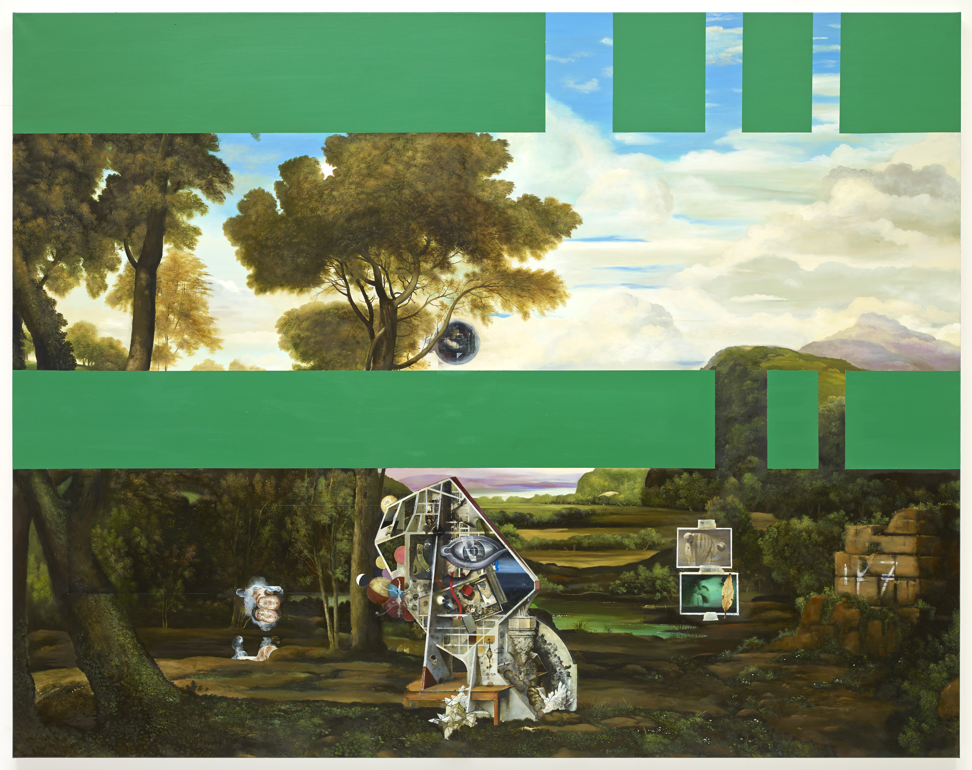
GED QUINN, Events Arrive on Doves’ Feet, 2014, Oil on linen, 78 ¾ x 100 in, 200 x 254 cm
© The artist and Stephen Friedman Gallery, London

Ged Quinn is celebrated for his densely layered paintings that transform art historical techniques into contemporary experience. He works in meticulous detail and executes with extraordinary technical skill. Under the artist's hand, the pastoral landscape and the domestic still life are transformed from the familiar to the fantastic. Multiple histories, narratives and mythological emblems collide. The interplay of elements drawn from Western cultural history, mythology, philosophy and the imagination create an engagement with the viewer that challenges and plays with preconceived notions of beauty and art.
Ged Quinn was born in 1963 in Liverpool, UK. In the 1980s and 90s, Quinn studied at the Ruskin School of Drawing, Oxford, UK; Slade School of Fine Art, London, UK; Kunstakademie, Düsseldorf, Germany; and Rijksakademie, Amsterdam, the Netherlands. Recent notable solo exhibitions include Rose, Cherry, Iron Rust, Flamingo (2017), Pearl Lam Galleries, Hong Kong, China; Ged Quinn (2014), Stephen Friedman Gallery, London, UK; Ged Quinn (2013–14) New Art Gallery Walsall, West Midlands, UK; and FOCUS: Ged Quinn (2012), Modern Art Museum of Fort Worth, Texas, USA. Notable group exhibitions include Synthetic Landscapes: Reviewing the ideal landscape (2017), Meadow Arts and Shrewsbury Museum and Art Gallery, Weston Park, Shifnal, UK; CLASSICICITY: Ancient art, contemporary objects (2015), Breese Little, London, UK; Cake and Lemon Eaters: Viktor Pivovarov and Ged Quinn (2014), Galerie Rudolfinum and The Gallery of Fine Arts in Ostrava, Czech Republic; Somos Libres II (2014), Pinacoteca Giovanni e Marella Agnelli, Turin, Italy; Looking at the View (2013), Tate Britain, London, UK; The Endless Rennaissance (2012), Bass Museum of Art, Miami, USA; and Beyond Reality: British Painting Today (2012), Galerie Rudolfinum, Prague, Czech Republic.

ABOUT GALLERIA MUCCIACCIA
Massimiliano Mucciaccia opened Galleria Mucciaccia in 2006, in the historical centre of Rome. Born into a family of gallerists and art patrons, Massimiliano grew up in the entourage of artists, curators and aficionados. Shortly after, he opened a second space in the beautiful setting of the Dolomite Mountains. Over the years, it has come to be known as an exclusive corner in Cortina d’Ampezzo where art lovers and collectors gather together during the winter season.
Massimiliano, as founding partner, opened Partners & Mucciaccia in Singapore, in 2012. Together with his partners, the gallery focuses on showcasing 20th century masters. The gallery holds solo exhibitions for their international artists, as well as showcasing artists from the region. Located in the prestigious and green district of Gillman Barracks, the gallery is a cultural hub and hosts a well-diverse events program for artistic thought-provoking debates.
On June 23, 2016, Partners & Mucciaccia opened in London. Situated in the heart of Mayfair, on the ground floor at 45 Dover Street, this new addition is the fourth branch to the group. The gallery’s vision is to explore the works of numerous artists and sculptors who sought new approaches to art, with a particular attention to the 20th and 21st century.
The identity of the gallery is defined for its strong exhibition program featuring leading modern and contemporary Italian and international artists. The gallery has built a reputation for working closely with curators to define and support the artistic career of their artists, highlighting their work on an international scale. It continuously works in collaboration with institutions and foundations, to organize museum-quality exhibitions, such as the retrospectives of Giorgio de Chirico, Robert Rauschenberg and Jacques Villeglé.

